

My Career

B.Sc.(Hons) in Software Development

Alexander Souza

[G00317835@GMIT.IE](mailto:G00317835@GMIT.IE)

Supervisor

Damien Costello

Submission Date 16th April 2018

GitHub

<https://github.com/alexpt2000gmit/4Year_MainProject_MyCareer>



Applicant Tracking System

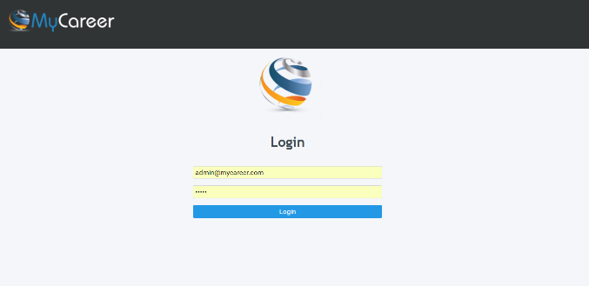

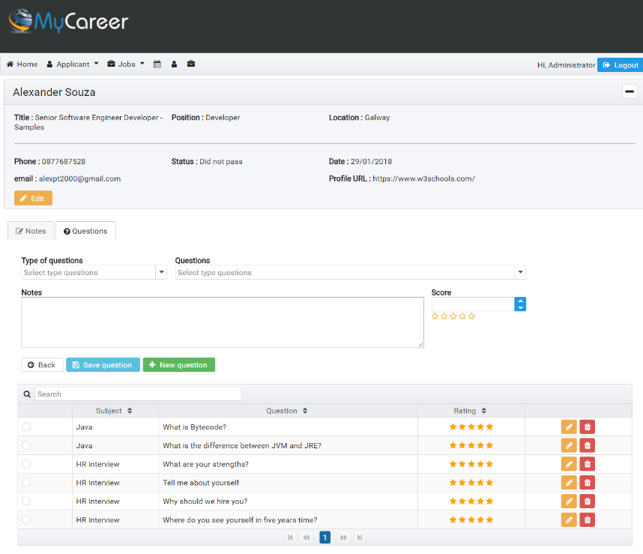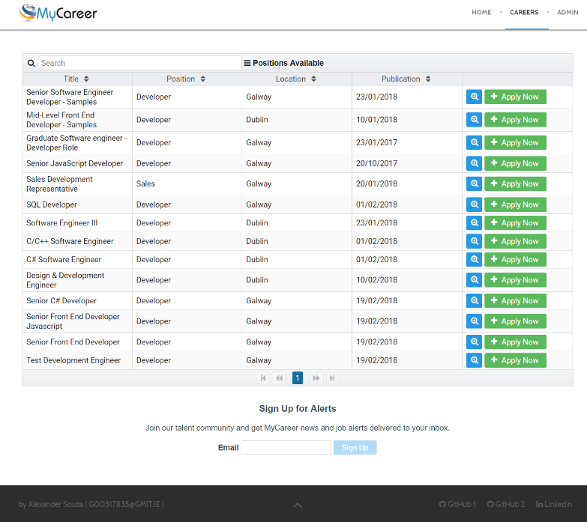

**Table of Contents**

1 Introduction 7

1.1 The Idea 7

1.2 The Application 7

1.3 Project Scope 7

1.4 Summary 7

2 Methodology 8

2.1 Planning 8

2.2 Methodology 8

2.3 Project Management 8

2.3.1 GitHub. 8

3 Technology Review 9

3.1 Java 9

3.2 Hibernate 9

3.3 JWT 9

3.4 Angular 4 9

3.5 Joomla 10

3.6 MySQL 10

3.7 Heroku 11

3.8 Amazon AWS 11

3.9 Spring Framework 11

3.10 GitHub 12

3.11 PrimeNG 12

3.12 Node.js 12

4 System Design 13

4.1 System Architecture 13

4.1.1 Web site 13

4.1.2 Front end (Applicants) 13

4.1.3 Back end (Applicants) 13

4.1.4 Security 13

4.1.5 API 13

4.1.6 Database 13

4.2 System Design 13

4.3 REST 14

4.3.1 Architectural constraints 14

4.3.2 HTTP methods 14

4.3.3 HTTP status codes 15

4.3.4 Design Patterns 15

4.4 System Deployment 15

4.4.1 Deploy Joomla (AWS) 16

4.4.2 Deploy Angular (Heroku) 18

4.4.3 Deploy API (Heroku) 18

5 System Evaluation 19

5.1 Robustness & Efficiency 19

5.1.1 Tomcat 19

5.1.2 MongoDB 19

5.2 Space / Time Complexity 19

5.3 Security and Validation 19

5.4 Deliverable Software Analysis 19

5.4.1 Limits of the system. 19

6 Conclusion 20

6.1 Summary 20

6.2 Learning Outcomes 20

6.3 Reflection 20

7 References 21

References 21

8 Appendices 22

**Table of Illustrations**

**Fig. 1.** System Architecture 13

**Fig. 2.** Deploy Joomla website - Configuration 16

**Fig. 3.** Deploy Joomla website - Database 17

**Fig. 4.** Deploy Joomla website - Overview 17

**Fig. 5.** Deploy Joomla website - Congratulations 18

**Abstract.**

1. Introduction
   1. The Idea
   2. The Application
   3. Project Scope
   4. Summary
2. Methodology
   1. Planning
   2. Methodology
   3. Project Management
      1. GitHub.
3. Technology Review

MyCareer is an enterprise web application and several technologies were used to build the applications;

* 1. Java

Java is a general-purpose computer-programming language that is concurrent, class-based, object-oriented, and specifically designed to have as few implementation dependencies as possible. It is intended to let application developers "write once, run anywhere" (WORA), meaning that compiled Java code can run on all platforms that support Java without the need for recompilation. Java applications are typically compiled to bytecode that can run on any Java virtual machine (JVM) regardless of computer architecture.



* 1. Hibernate

Hibernate ORM (Hibernate in short) is an object-relational mapping tool for the Java programming language. It provides a framework for mapping an object-oriented domain model to a relational database. Hibernate handles object-relational impedance mismatch problems by replacing direct, persistent database accesses with high-level object handling functions.



* 1. JWT

JSON Web Token (JWT) is a compact token format intended for space constrained environments such as HTTP Authorization headers and URI query parameters. JWTs encode claims to be transmitted as a JSON object that is base64url encoded and digitally signed and/or encrypted. Signing is accomplished using JSON Web Signature (JWS). Encryption is accomplished using JSON Web Encryption (JWE).



* 1. Angular 4

Angular (commonly referred to as "Angular 4" or "Angular 2") is a TypeScript-based open-source front-end web application platform led by the Angular Team at Google and by a community of individuals and corporations. Angular is a complete rewrite from the same team that built AngularJS.



* 1. Joomla

Joomla! is a free and open-source content management system (CMS) for publishing web content. Over the years Joomla! has won several awards. It is built on a model–view–controller web application framework that can be used independently of the CMS that allows you to build powerful online applications.

Joomla! is one of the most popular website softwares, thanks to its global community of developers and volunteers, who make sure the platform is user friendly, extendable, multilingual, accessible, responsive, search engine optimized and so much more.

Joomla! can be used for:

* Corporate websites or portals, intranets and extranets
* Small business websites
* Online magazines, newspapers, and publications
* E-commerce and online reservations
* Government, non-profit and organisational websites
* Community-based, school and church websites or portals
* Personal or family homepages ...

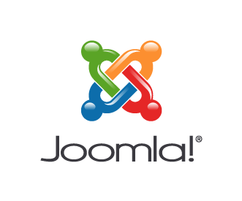

* 1. MySQL

MySQL is an open-source relational database management system (RDBMS). Its name is a combination of "My", the name of co-founder Michael Widenius's daughter, and "SQL", the abbreviation for Structured Query Language. The MySQL development project has made its source code available under the terms of the GNU General Public License, as well as under a variety of proprietary agreements. MySQL was owned and sponsored by a single for-profit firm, the Swedish company MySQL AB, now owned by Oracle Corporation. For proprietary use, several paid editions are available, and offer additional functionality.

MySQL is a central component of the LAMP open-source web application software stack (and other "AMP" stacks). LAMP is an acronym for "Linux, Apache, MySQL, Perl/PHP/Python". Applications that use the MySQL database include: TYPO3, MODx, Joomla, WordPress, Simple Machines Forum, phpBB, MyBB, and Drupal. MySQL is also used in many high-profile, large-scale websites, including Google, Facebook,Twitter, Flickr, and YouTube.



* 1. Heroku

Heroku is a cloud platform as a service (PaaS) supporting several programming languages that is used as a web application deployment model. Heroku, one of the first cloud platforms, has been in development since June 2007, when it supported only the Ruby programming language, but now supports Java, Node.js, Scala, Clojure, Python, PHP, and Go. For this reason, Heroku is said to be a polyglot platform as it lets the developer build, run and scale applications in a similar manner across all the languages.



* 1. Amazon AWS

Amazon Web Services (AWS) is a subsidiary of Amazon.com that provides on-demand cloud computing platforms to individuals, companies and governments, on a paid subscription basis. The technology allows subscribers to have at their disposal a full-fledged virtual cluster of computers, available all the time, through the Internet.



* 1. Spring Framework

The Spring Framework is an application framework and inversion of control container for the Java platform. The framework's core features can be used by any Java application, but there are extensions for building web applications on top of the Java EE (Enterprise Edition) platform. Although the framework does not impose any specific programming model, it has become popular in the Java community as an addition to, or even replacement for the Enterprise JavaBeans (EJB) model. The Spring Framework is open source.



* 1. GitHub

GitHub (originally known as Logical Awesome LLC) is a web-based hosting service for version control using git. It is mostly used for computer code. It offers all of the distributed version control and source code management (SCM) functionality of Git as well as adding its own features. It provides access control and several collaboration features such as bug tracking, feature requests, task management, and wikis for every project.

GitHub offers plans for both private repositories and free accounts which are commonly used to host open-source software projects. As of April 2017, GitHub reports having almost 20 million users and 57 million repositories, making it the largest host of source code in the world.



* 1. PrimeNG

PrimeNG is a collection of rich UI components for Angular. All widgets are open source and free to use under MIT License. PrimeNG is developed by PrimeTek Informatics, a vendor with years of expertise in developing open source UI solutions.



* 1. Node.js

Node.js is an open-source, cross-platform JavaScript run-time environment for executing JavaScript code server-side. Historically, JavaScript was used primarily for client-side scripting, in which scripts written in JavaScript are embedded in a webpage's HTML, to be run client-side by a JavaScript engine in the user's web browser. Node.js enables JavaScript to be used for server-side scripting, and runs scripts server-side to produce dynamic web page content before the page is sent to the user's web browser.

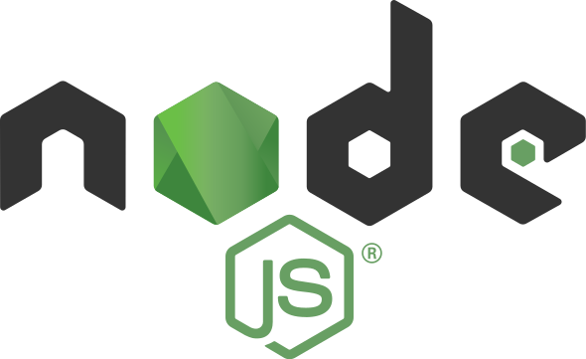

1. System Design
   1. System Architecture

The MyCareer application has been completely created from the ground up using a methodical and structured approach.

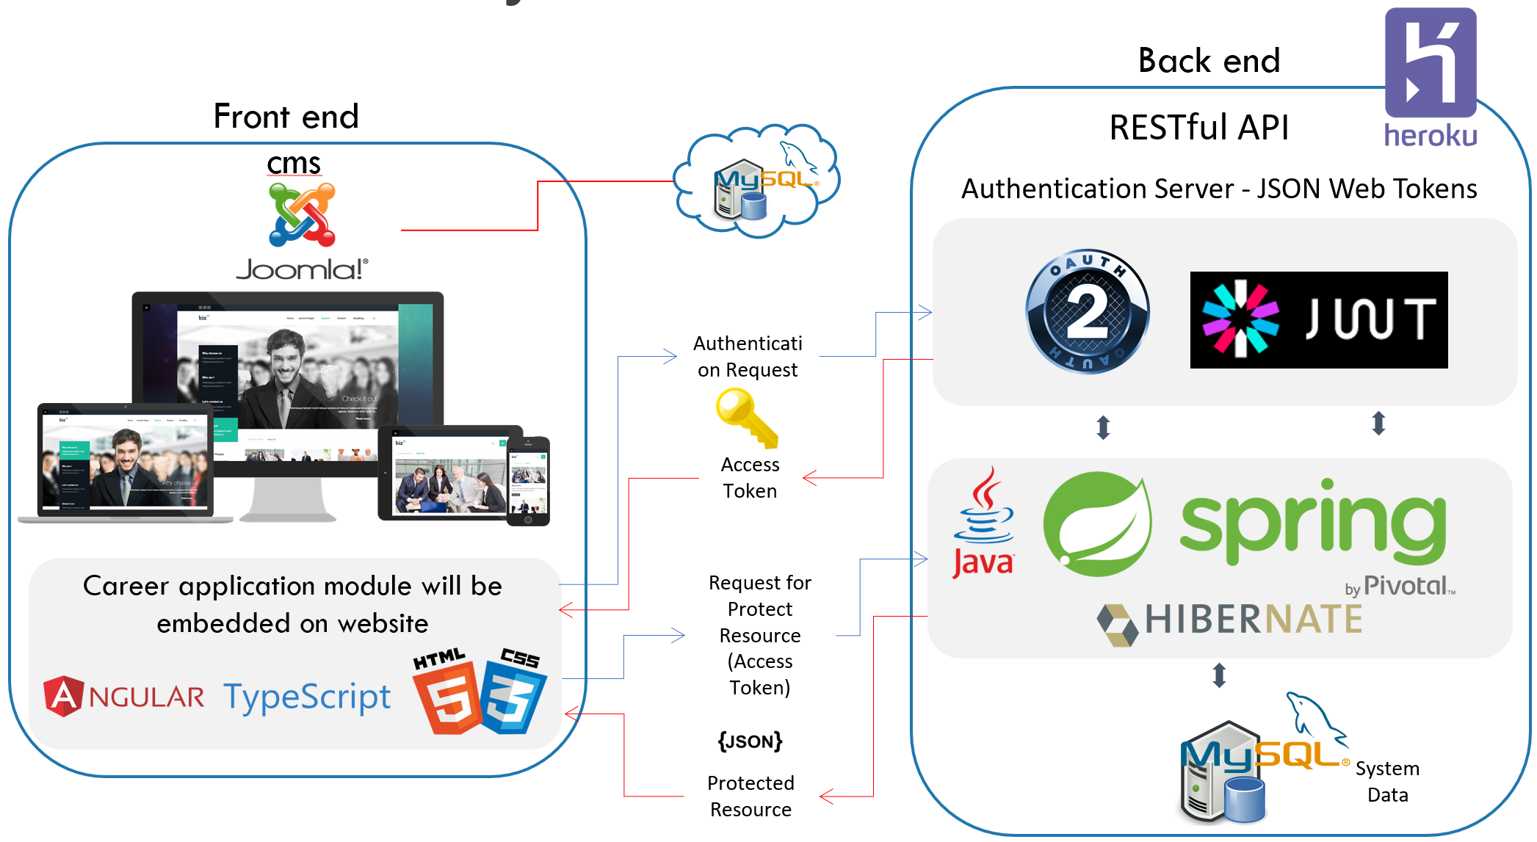

**Fig. 1.** System Architecture

* + 1. Web site
    2. Front end (Applicants)
    3. Back end (Applicants)
    4. Security
    5. API
    6. Database
  1. System Design

Languages, tools, and technologies used during development are key factors in making applications different from one another. Once decisions are made on which tools and technologies to use, the overall system architecture, entity-relationship model, and REST API and Front-end.

* 1. **REST**

REST stands for Representational State Transfer. REST architecture style is mainly based on the stateless, client-server and HTTP protocol. This architectural style is a key aspect in designing network applications and distributed systems. REST does not completely rely on HTTP but mostly linked with it. The properties of REST play the vital role in the REST architecture style and make the REST architecture simpler. REST architecture is a lightweight alternative to other mechanisms like RPC4, SOAP5, and WSDL6. Moreover; REST is a platform-independent, and language-independent service. The following sub-sections explain in detail about REST.

* + 1. Architectural constraints

REST has a set of constraints to components, data elements, and connectors. The main constraints include client-server, stateless, layered system and uniform interface.

1. **Client-server:**

The client-server constraint is the most common constraint where the user-interface separates the clients from servers. Some properties or features are not mandatory for the clients, but some of those properties are important of servers. For example, some database related codes are not important to be present in client side, but it is more important for the server. Hence, portability of the code can be improved on the client side.

1. **Stateless:**

The client-server communication must be stateless in nature. The stateless nature is because that server must have all the information that are needed to respond to the request made by the client. The session state entirely depends on the client. In this constraint, the properties such as visibility, scalability and reliability are improved based on different aspects. The main drawback is that is the decrease in the performance of the network by sending the same data in the cluster of requests.

* + 1. HTTP methods

HTTP methods are used to map CRUD operations to HTTP requests. HTTP methods are used with REST to form as a RESTful service. GET, POST, PUT, and DELETE are the four main HTTP methods.

1. **GET**

‘GET’ is used to retrieve the data from the database. The GET requests can be partial or conditional. The partial request retrieves all the information from the particular table. The conditional request retrieves only the specific data from the database based on the condition.

**Example**:

GET /applicants – gets all the plants of the respective table

GET / applicants /1 – gets the plant with an ID of 1 of the respective table

1. **POST**

This HTTP method is mainly used to create a new entity in the table. However, it can also be used for update an existing entity.

**Example**:

POST / applicants – creates a new plant

1. **PUT**

Like POST, ‘PUT’ can be used to create a new entity and also used to update an existing entity in the table. PUT is idempotent.

**Example**:

PUT /applicants /1 – update the plant with an ID of 1

1. **DELETE**

If a resource has to be removed, then DELETE method can be used.

**Example**:

DELETE / applicants /1 – deletes the plant with an ID of 1

* + 1. HTTP status codes

HTTP response status codes are the codes that are results of the HTTP requests. When an HTTP request is made from the client, the server will send an appropriate status code along with the data, if any. The browser translates these status codes. The types of HTTP status codes are:

* 1XX - informational
* 2XX - success
* 3XX - redirection
* 4XX – client error
* 5XX – server error
  + 1. Design Patterns

Design Patterns are general reusable solutions to commonly occurring problems. Patterns are not complete code, but it can be uses as a template which can be applied to a problem. Patterns are re-usable and they can be applied to similar kinds of design problems regardless of the domain. A pattern used in one practical context can be re-usable in other contexts also. Here are some of the reasons to use design patterns;

1. **Flexibility**: Using design patterns makes code flexible. It helps to provide the correct level of abstraction due to which objects become loosely coupled to each other which makes the code easy to change.

2. **Reusability**: Loosely coupled and cohesive objects and classes can make the code more reusable. This kind of code becomes easy to be tested as compared to the highly-coupled code.

3. **Shared** Vocabulary: Shared vocabulary makes it easy to share the code with other team members. It creates more of an understanding between the team members in relation to the code.

4. **Capture** best practices: Design patterns capture solutions which have been successfully applied to problems. By learning these patterns and the related problems, an inexperienced developer learns a lot about software design.

* 1. System Deployment

The best practice to deploy a spring boot and angular application is to separate the user interface code with the business logic. This provides decoupling of the client code with server code and hence the application becomes highly scalable and manageable. The fronted developer can continue with the fronted development in parallel with the backend developer. The backend code becomes free to use and integrate different technology stacks and it becomes available for multiple clients such as the same APIs can be re-used for building android application and same can be integrated with third party clients too. It also reduces the downtime of your application. Whenever, your APIs are not available or down, your client application is still up.

But sometimes it becomes an overhead to manage two server for a small team and a small application. If a single full stack developer is handling all the UI and server related configurations, packaging fronted and backend application into a single web application is sometimes more helpful. Still, you can expose REST APIs and integrate angular fronted code within the same application and deploy to a tomcat and other mobile client can reuse the same APIs.

* + 1. Deploy Joomla (AWS)

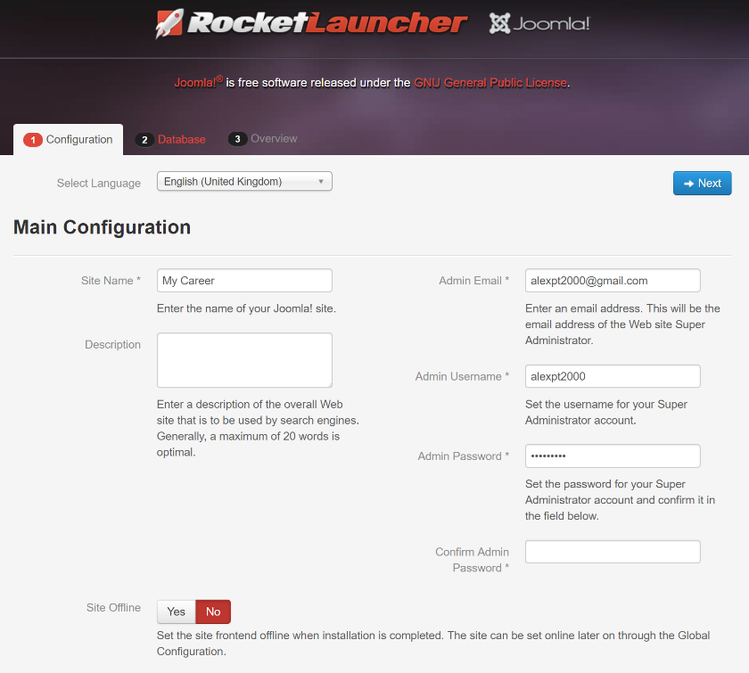

**Fig. 2.** Deploy Joomla website - Configuration

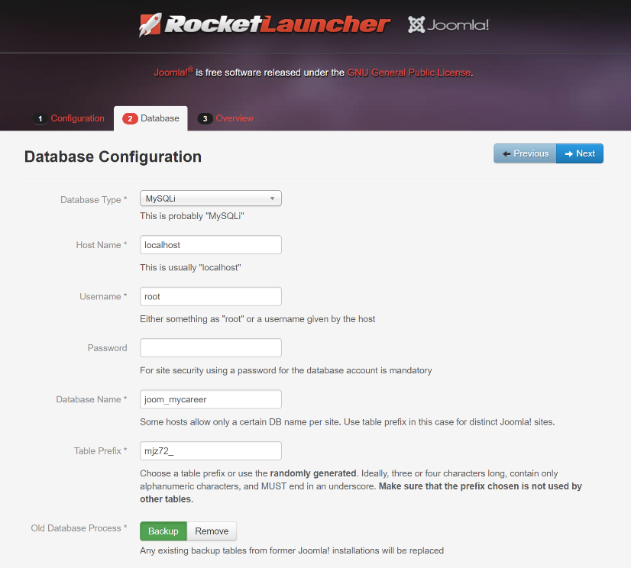

**Fig. 3.** Deploy Joomla website - Database

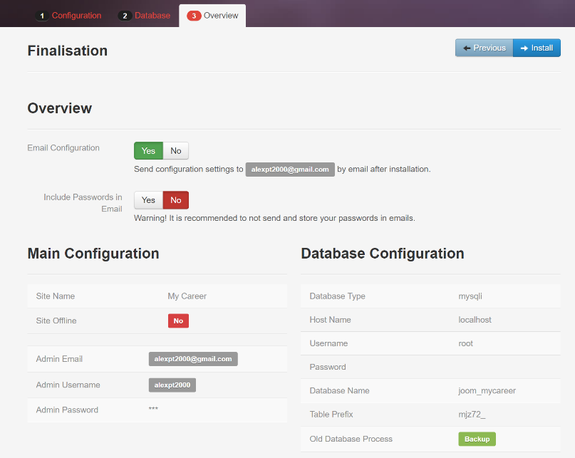

**Fig. 4.** Deploy Joomla website - Overview

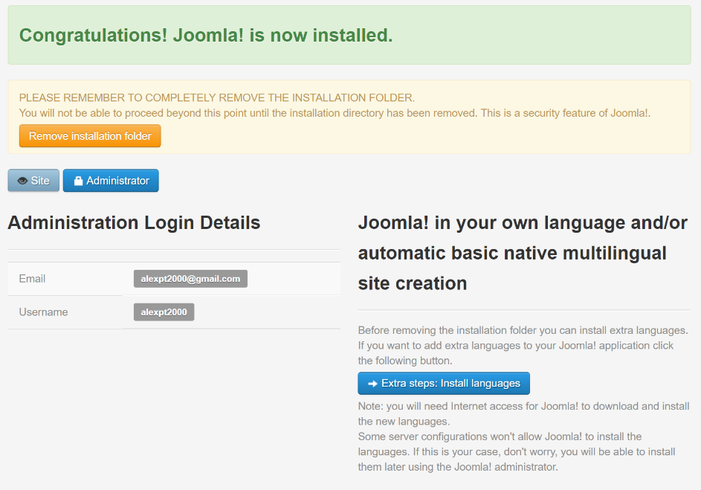

**Fig. 5.** Deploy Joomla website - Congratulations

* + 1. Deploy Angular (Heroku)
    2. Deploy API (Heroku)

1. System Evaluation
   1. Robustness & Efficiency
      1. Tomcat
      2. MongoDB
   2. Space / Time Complexity
   3. Security and Validation
   4. Deliverable Software Analysis
      1. Limits of the system.
2. Conclusion
   1. Summary
   2. Learning Outcomes
   3. Reflection
3. References

# References

|  |  |
| --- | --- |
| [1] | "Fielding, R. T.; Taylor, R. N. (2000), Principled design of the Modern Web". |

1. Appendices